Thanh Minh

Task 1: Set up and test your use account on Mercury

Step 1: Log onto the web server and set up your account

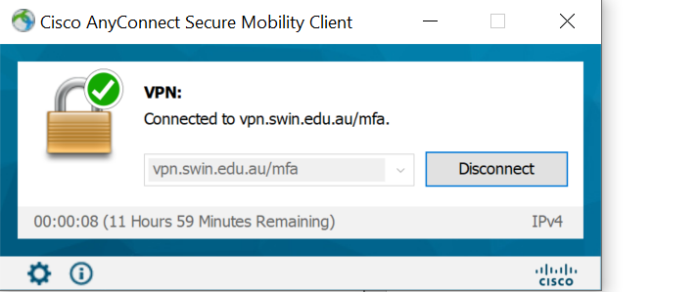

Step 2:

Step 3: Create a folder to contain your web pages

Step 4: create a web page for testing

Stage 5: transfer your web page to the web server

Step 6:

Task 2: Validate your web page as html5

I use the Dreamweaver so I can validate within the app

